**DAILY ASSESSMENT FORMAT**

|  |  |  |  |
| --- | --- | --- | --- |
| **Date:** | **01/06/2020** | **Name:** | **Neha T** |
| **Course:** | **Network Theory** | **USN:** | **4AL18EC035** |
| **Topic:** | **1.Network Terminology**  **2.Basic circuit analysis**  **3.Different types of matrix & its application** | **Semester & Section:** | **4th Sem**  **‘A’ Section** |
| **Github Repository:** | **Neha-T** |  |  |

**FORENOON SESSION**

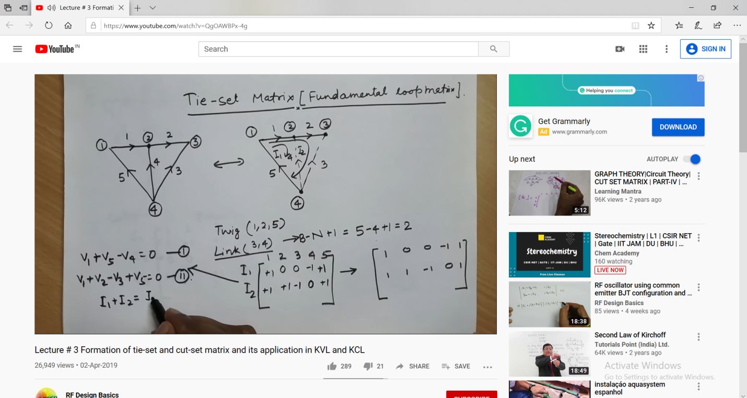

**REPORT**

* **Network terminology**
* **Nodes**
* **Branches**
* **Loops or meshes**
* **Branch currents & mesh currents**
* **Node voltages & Junction node voltages**
* **Basic circuit analysis & network topology**
* **Overview of analysis**
* **Serial/parallel reduction**
* **Voltage/current division**
* **Ladder circuit**
* **Network topology is a graphical representation of electric circuits.**
* **It is useful for analyzing complex electric circuits by converting them into network graphs. Network topology is also called as Graph theory.**
* **Graph of a network**
* **Network graph is simply called as graph.**
* **It consists of a set of nodes connected by branches. In graphs, a node is a common point of two or more branches. Sometimes, only a single branch may connect to the node. A branch is a line segment that connects two nodes.**
* **Incidence matrix**
* **An Incidence Matrix represents the graph of a given electric circuit or network. Hence, it is possible to draw the graph of that same electric circuit or network from the incidence matrix.**
* **Formation of tie-set and cut-set matrix**
* **Tie-Set: It is a unique set with respect to a given tree at a connected graph containing on chord and all of the free branches contained in the free path formed between two vertices of the chord.**
* **Cut-Set: It is that set of elements or branches of a graph that separated two parts of a network. If any branch of the cut-set is not removed, the network remains connected. The term cut-set is derived from the property designated by the way by which the network can be divided in to two parts.**
* **Tie-set & cut-set matrix applications in KVL & KCL were also discussed.**

**AFTERNOON SESSION**

|  |  |  |  |
| --- | --- | --- | --- |
| **Date:** | **01/06/2020** | **Name:** | **Neha T** |
| **Course:** | **Network Theory** | **USN:** | **4AL18EC035** |
| **Topic:** | **1.Network Terminology**  **2.Basic circuit analysis**  **3.Different types of matrix & its application** | **Semester & Section:** | **4th Sem**  **‘A’ Section** |
| **Github Repository:** | **Neha-T** |  |  |

Image of the session

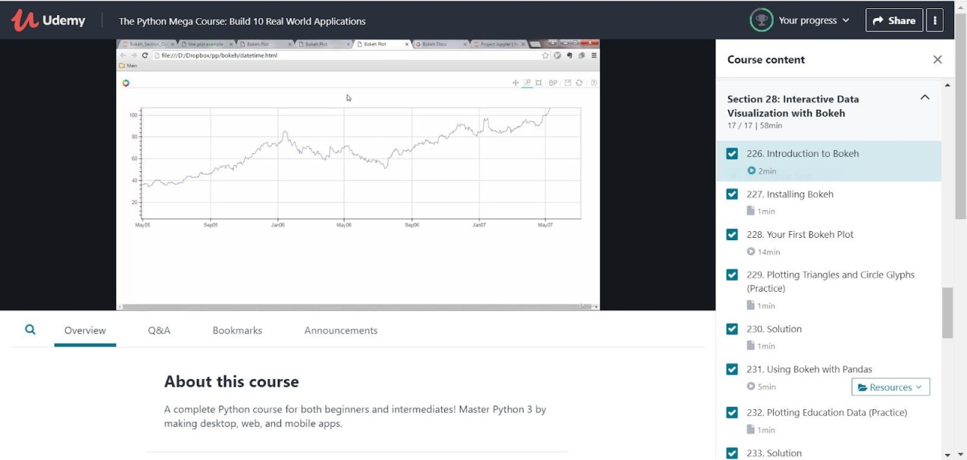

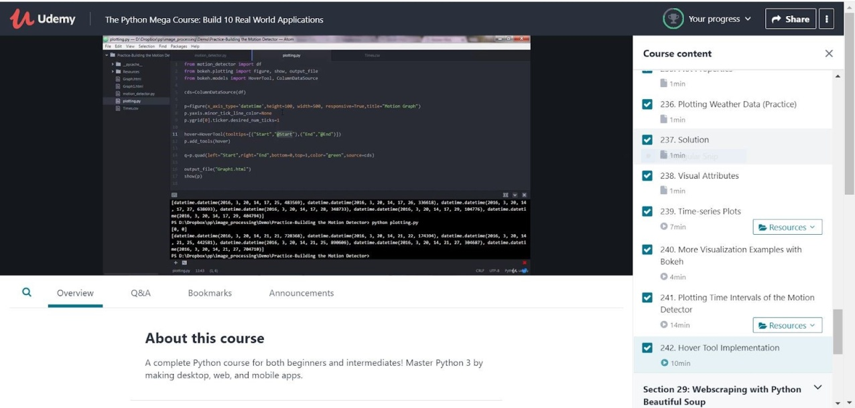

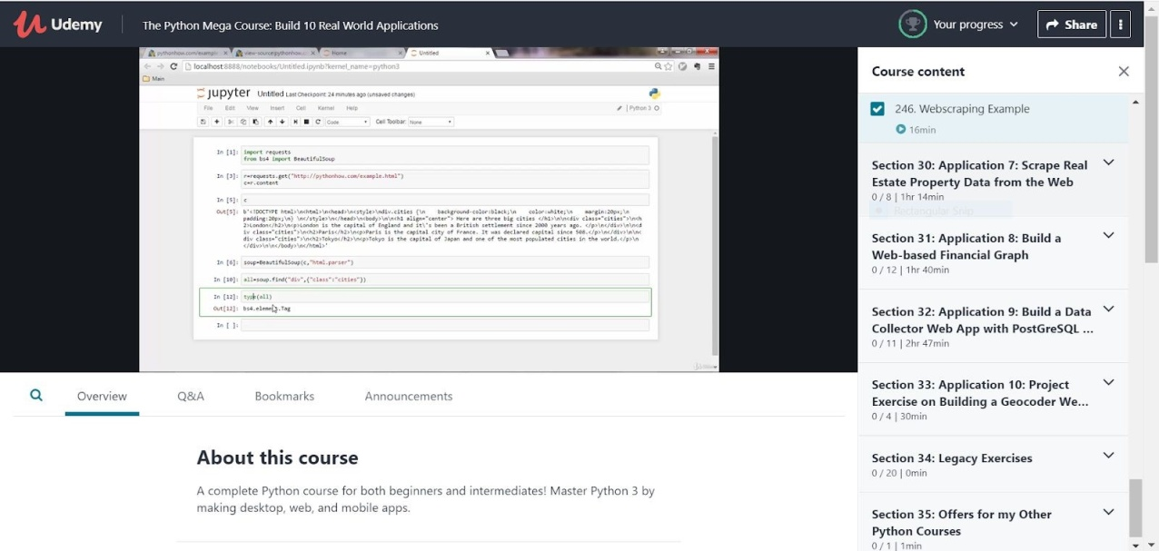

➢ Interactive Data Visualization with Bokeh

* Introduction to Bokeh
  + Bokeh is a Python interactive visualization library that targets modern web browsers for presentation providing elegant, concise construction of novel graphics with high-performance interactivity over very large or streaming datasets in a quick and easy way.
  + Offering both powerful and flexible features to enable very advanced customizations in one hand and simplicity on the other, Bokeh exposes different interface levels to the users: A ​*low-level*​ ​[bokeh.models](https://docs.bokeh.org/en/0.10.0/docs/reference/models.html" \l "bokeh-models)​ interface that provides the most flexibility to application developers. An *intermediate-level*[​](https://docs.bokeh.org/en/0.10.0/docs/reference/plotting.html#bokeh-plotting) [bokeh.plottin](https://docs.bokeh.org/en/0.10.0/docs/reference/plotting.html#bokeh-plotting)​ [g](https://docs.bokeh.org/en/0.10.0/docs/reference/plotting.html#bokeh-plotting) interface that is centered around​ composing visual glyphs. A ​*high-level*[​](https://docs.bokeh.org/en/0.10.0/docs/reference/charts.html#bokeh-charts) ​[bokeh.charts](https://docs.bokeh.org/en/0.10.0/docs/reference/charts.html" \l "bokeh-charts)​interface that can be used to build complex statistical plots as quickly and as simply as possible. This Quickstart focuses on the ​[bokeh.plotting](https://docs.bokeh.org/en/0.10.0/docs/reference/plotting.html" \l "bokeh-plotting)​interface

* Installing Bokeh

* First Bokeh Plot
  + Plots are a central concept in Bokeh. They are containers that hold all the various objects (renderers, guides, data, and tools) that comprise the final visualization that is presented to users

* Using Bokeh with Pandas

* Plot properties were also discussed.